

Publisher is a powerful software application used for desktop publishing. It allows you to manipulate features such as page size, text, graphics, and borders. Publisher tools below:

**Key Words / Key Facts**

**Yr9 HT4 – IT Project**

|  |  |
| --- | --- |
| **Word** | **Definition** |
| **Emerging** | Starting to exist |
| **Technology** | Technology refers to methods, systems, and devices which are the result of scientific knowledge being used for practical purposes. |
| **Artificial intelligence** | Uses computers and machines to mimic the problem-solving and decision-making capabilities of the human mind |
| **Virtual reality** | a computer-generated environment with scenes and objects that appear to be real, making the user feel they are immersed in their surroundings. |
| **Augmented reality** | a technology that superimposes a computer-generated image on a user's view of the real world, thus providing a composite view. |
| **Design principles** | The rules a designer must follow to create an effective graphic product. |
| **Planning** | The process of making plans for something. |
| **Designing** | to create, fashion, execute, or construct according to plan |
| **Drones** | A drone is an unmanned aircraft. |
| **Evaluation** | The making of a judgement about the amount, number, or value of something; assessment. |

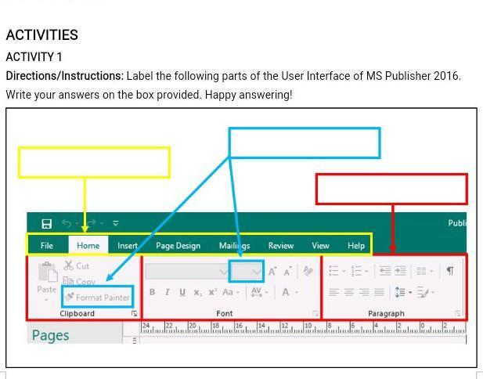

Tabs

Clipboard & fonts

Paragraphs

**Magazine covers**

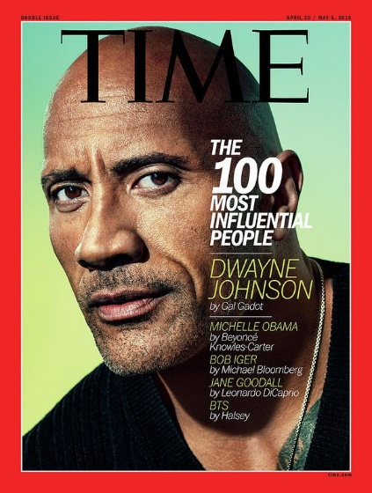

* Artificial intelligence​
* Virtual reality ​
* Augmented reality ​
* Cryptocurrencies ​
* Robotization​
* Autonomous Driving​
* Drones ​

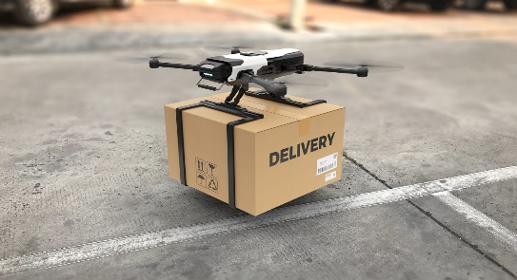

**Emerging technologies**

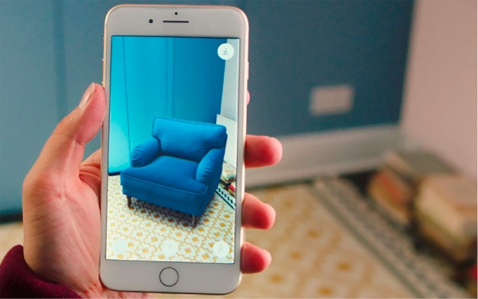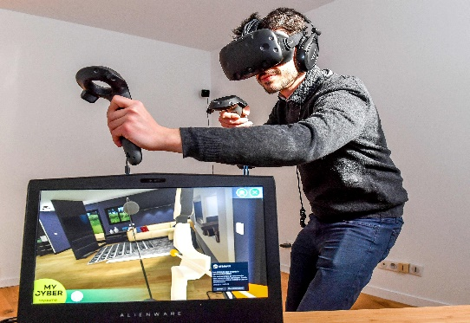

**You need to be able to answer.**

|  |  |
| --- | --- |
| **KQ1 – How will emerging technologies impact individuals in the future?** |  |
|  |  |
| **KQ2 – How does design influence how information should be presented** |  |
|  |  |
| **KQ3 – What design features can be used to create a magazine?** |  |
|  |  |